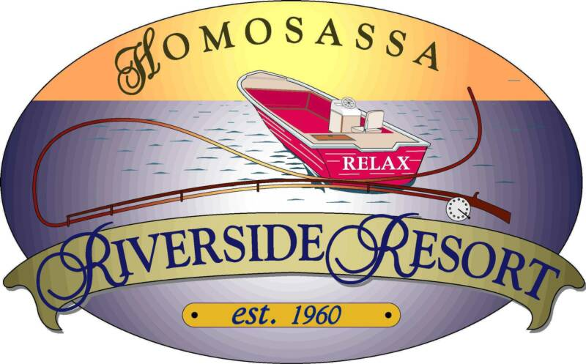
Relay For Life 2nd Annual Family Fun Fishing Tournament

Saturday September 28, 2013 - Homosassa Riverside Resort

Tournament Fee: $100 per boat- 50%-Proceeds goes Relay for Life, 50% Prize $

MANDATORY- Captains Meeting, Friday Sept 27 ^{th} - 6:30pm-8:00pm-No Entrants after 8:00pm
Start @ 7:30 am, Weigh In @ 4pm - must be in line - No Exceptions!
Plenty of Prizes for Adults & Children - Chance Raffles & 50/50 Drawing
Point System determines Money Winners, Species Included in Tournament; Black Fish (Sea Bass), Trout, Mangrove Snapper, Flounder, Redfish, Black Drum, Sheep Head & Grouper.
Point System- Fishing Categories-One weigh in- 1 Fish per category per boat
Prize $$ Prize $ - Based on 100 Boats-Payouts as follows:
EXAMPLE:
Red Fish= 1 pt
Trout = 2pts
Sea Bass= 4pts
M. Snapper=3pts
*TOTAL = 10pts *
1^{st -} $2500 Red Fish - 1pt Black Drum – 3pts
2^{nd -} $1500 Grouper - 2pts Mangrove Snapper – 3pts
3rd - $500 Trout – 2pts Black Fish (Sea Bass) – 4pts
4th - $300 Sheepshead – 3pts Flounder – 5pts
5th - $200 Total Points Win, Total Bag Wt. Tie Breaker.
Prize for the Highest Total Weight of ONE FISH (No shark or stingray) - Children 12 & under.
SPONSOR LEVELS: GOLD $250, PLATINUM $500, DBL PLATINUM $1000.
Make checks payable to Team Hope, American Cancer Society
To register, contact Michele Snellings@duke-energy.com at 352-697-2220 or Nick Maltese@duke-energy.com at 352-464-7511.
Pre- Register at: Eagle Buick GMC , Blue Water Bait & Tackle, or Homosassa Riverside Resort in Homosassa.
In Crystal River: Moore’s Bait & Tackle, Preferred Auto Services or D.J MCCABE’s Custom Paint & Body Shop
Registrations must be rec’d by Sep 21st- limited 200 Boats- Registration day of event $125 per boat, cash-only.
Captain & Boat Name ____________________________ Contact # _______________
Team Hope assumes no responsibility for liability or loss during this Tournament.
Homosassa Riverside Resort located at 5297 S. Cherokee Way, Homosassa, (352) 628-2474 Has discounted rooms available for this Tournament. 2 DBLS or 1 KING $65 per night, go to www.riversideresorts.com Be sure mention-Team Hope Relay 4 Life Fishing Tournament.

.

