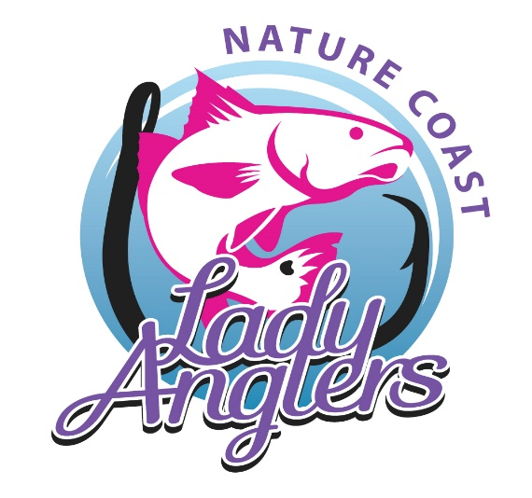
2019
FISH LIKE A Girl
Tournament
4th Annual Lady Angler Fishing Competition
Catch-Photo-Release Event
with
62 Days of Fishing!!
Begins: Tuesday, October 1, 2019 @ Sunrise
Ends: Sunday, December 1, 2019 @ Sunset
Winners will be determined by a random drawing (Not the Biggest Fish)
(See Tournament Rules for more Information)
Divisions:
Redfish
Spotted Trout
Snook
Conservation
Entry Fee: $50.00
For more information on the FLAG Tournament visit our Facebook page “Nature Coast Lady Anglers” or www.naturecoastladyanglers.com

TOURNAMENT HOST: The Nature Coast Lady Anglers, hereinafter known as NCLA, is the host of the 4th Annual Fish Like A Girl Tournament. Net profit from this event will be used to support charitable endeavors in the Nature Coast area. NCLA reserves the right to amend these rules or make exceptions at any time.
TOURNAMENT DESCRIPTION: The intent of this tournament is to catch, photograph and release fish caught during official tournament hours. NCLA supports marine life conservation efforts and hopes that you will release all captured fish and other marine life. If you keep all or a portion of your catch you will not be disqualified from the tournament but please understand it is your responsibility to abide by all current State of Florida fishing rules and regulations including but not limited to species, size, slot, limits, etc. NCLA assumes no responsibility for your failure to do so. One of the advantages of a photo tournament is that you can win with fish outside any slot limits for their species which you could not legally land for a physical weigh-in.
PARTICIPATION AND ELIGIBILITY: Participation is open to all NCLA members and or Lady Anglers. Participants must have a current Florida Fishing License as required by state law.
REGISTRATION & FEES: Registration will remain open throughout the month of October 2019. Each participant must register and pay for the tournament the required fee of $50.00 (Fifty dollars). The entry fee is due when the tournament application is submitted.
CAPTAINS’ MEETING: WHEN - Friday, September 27, 2019 from 6:00 PM to 8:00 PM.
WHERE – The Elegant Pelican - 7395 W. Pinebrook St., Crystal River FL 34429
Attendance at the Captains’ Meeting is not Mandatory.
LEGAL FISHING METHODS: All fish entered into competition for prizes, must been caught and landed by the registered participant. All fish entered into competition for prizes must have been hooked and caught by the contestant on rod, reel, hook and line. Live bait, frozen bait and all artificial lures will be allowed. Only standard conventional, spin, or fly tackle may be used. Fishing is permitted from a boat, kayak and also from docks, piers, seawalls, shorelines as is wade fishing.
Tournament Boundaries: FLAG boundaries are the territorial waters of the Gulf of Mexico, Atlantic Ocean and Florida Bays for the State of Florida.
MEASURING METHODS AND FISH ENTRY: ALL entries must be electronically submitted by using the tournament protocols, either by a direct upload using the I Angler Tournament official smart phone application or by using the Nature Coast Lady Anglers website and accessing the 2019 FLAG Tournament Link within 24 hours of each catch. Each entry must include a digital photograph of the fish with the 2019 FLAG Tournament measuring device or with a 2019 FLAG Token clearly visible on a measuring device that will photograph clearly and show measurements.
Electronic submission of all tournament entries must also include the tournament Division-Species (Redfish, Spotted Trout, Snook or Conservation) Length, Time, Date, Name of Angler. All fish entered shall be photographed and entered only once and only one fish per participant, per species, per day may be entered in the tournament, except for the Conservation Division.
Redfish, Spotted Trout and Snook Division: All fish have to meet minimum size requirements to qualify for entry in their divisions, using the FWC prescribed measurement required for each species. Winners of the Redfish, Spotted Trout and Snook Divisions will be determined by a drawing.

Conservation Division: Any species of fish of any length caught by FLAG participants are eligible for entry in this division. Entries must follow the measuring and fish entry requirements and are also only to be photographed and entered only once and only one fish per participant, per species, per day. Fish entered in other divisions are not eligible for entry in the Conservation Division. Winners of the Conservation Division will be determined by a drawing.

TOURNAMENT MEASURING DEVICES AND TOKENS: All participants will be provided with a Tournament measuring device or Token at the Captains’ Meeting. or by E-mail where a Token can be copied and used.
The official 2019 FLAG Measuring Device or 2019 FLAG Token will be available and can be obtained (after 9/27/19) at:
Captain’s Meeting – September 27, 2019 at the
Elegant Pelican, Crystal River Country Club 7395 W. Pinebrook St, Crystal River, FL 34429 6:00 to 8:00 PM
Moore’s Bait and Tackle – 9687 W. Fort Island Trail, Crystal River FL 34429
Hook-Line & Sinker Bait & Tackle – 144 Hwy 40 W, Inglis, FL 34449

Ozello Marina – 2355 S. Ripple Path, Crystal River, FL 34429 (Ozello)

Or contact: Lori Davis: 352-348-0743 - gldavis352@gmail.com
Rita Ranize: 352-459-2553 - redo237@comcast.net

If an angler is registered and unable to pick up a device, they should contact Rita Ranize or Lori Davis and a 2019 Token can be emailed and then copied for use immediately.

PHOTOS – GENERAL: The whole fish, measuring device with the Tournament measuring device and/or Token must be clearly visible in each photograph of entry. Printed photographs will not be accepted. No altered photos may be entered. Signing the tournament application grants full permission to NCLA and any and all sponsors of this event or their representatives to use any photograph, video, or any other records of this event for any purpose whatsoever.
SCORING: Winners of all Divisions will be determined by a random drawing.
AWARDS AND PRIZES: Fishing awards will be given out:
WHEN: Saturday, December 7, 2019 from 4:00 PM to 6:00 PM
WHERE: The Elegant Pelican – 7395 W. Pinebrook St., Crystal River, FL 34429
Contact Information: Rita Ranize: 352-459-2553 - redo237@comcast.net
Lori Davis: 352-348-0743 - gldavis352@gmail.com

